AMKmotion very satisfied with SPS in Nuremberg:
Energy efficiency comes up trumps
Successful SPS in Nuremberg for AMKmotion. The experts for electric drive systems presented their entire portfolio of solutions and expertise. With its focus on energy efficiency, AMKmotion was perfectly in line with current needs.
“Our stand was always packed,” says AMKmotion Product Manager Volker Schwarzkopf. The modern exhibition booth with its eye-catching exhibits and focus on energy efficiency attracted a diverse mix of old acquaintances, new customers and interested visitors. “We had lots of great discussions and planned some exciting future projects with our customers,” says Alexander Hipp, Director Sales & Customer Solution Centre. “Visitors were particularly interested in our hybrid drive technology and the benefits they can gain from energy-efficient solutions.”
The best of both worlds
Highly efficient systems can be set up using intermediate energy storage and energy recovery, for example: the compact power feed KES transfers regenerative energy back to the grid by means of sinus commutation. “This reduces electricity costs and the user is less dependent on the local power supply voltage thanks to the adjustable DC bus,” explains Marc Scheer, Head of Inside Sales. What is more, modularized mechanical engineering uses decentralized drives that do their job directly at the point of action.
Power-intensive processes usually require the installation of a central automation solution with a switch cabinet. “If users combine both approaches, they can enjoy the benefits of each. This works particularly easily if the components are at home in both worlds – as is the case with our KHY hybrid distributor,” says Scheer. The latter simplifies the combination of different signals and supply voltages from the central drive. As such, it serves as an intelligent interface to the decentralized drive world, such as and the compact and energy-efficient drive systems of the ihX series.

Partnership with SDT
Drive technology specialist SDT from Sweden was among those impressed by the possibilities offered by AMKmotion’s solutions. The two companies signed a contract at SPS: in future SDT will act as a trading partner, distributing the entire AMKmotion portfolio in Scandinavia while also using it as a system integrator in its own applications. “We’re very proud to have been able to gain such a strong partner in Scandinavia, and we look forward to a successful collaboration with SDT,” says Hipp.
The next opportunity to get a first-hand look at AMKmotion’s solutions will be on 5 and 6 March in Hall B1, Stand 530 of the trade fair all about automation in Friedrichshafen.
2.850 Zeichen inkl. Leerzeichen
Service for editorial departments
Meta-Title: AMKmotion very satisfied with trade fair appearance at SPS
Meta Description: Successful SPS in Nuremberg for AMKmotion. A modern exhibition booth with eye-catching exhibits and a focus on energy efficiency attracted a diverse mix of old acquaintances, new customers and interested visitors.
Social media: Lots of visitors, great discussions and a new trading partner for Scandinavia, namely SDT from Sweden – AMKmotion can look back on a successful SPS in Nuremberg. The expert for electric drive systems presented its entire portfolio of solutions and was perfectly in line with current needs with its focus on energy efficiency.

Captions
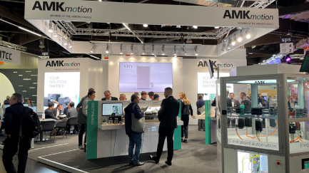
Image 1: There was constant action at AMKmotion’s modern trade fair stand at SPS 2023
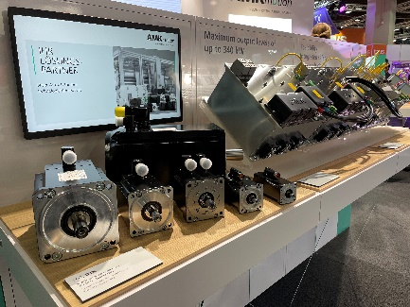
Image 2: Eye-catching exhibits and a focus on energy efficiency attracted lots of interested visitors.
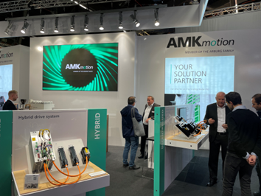
Image 3: The trade fair team had lots of great discussions and secured more exciting future projects.
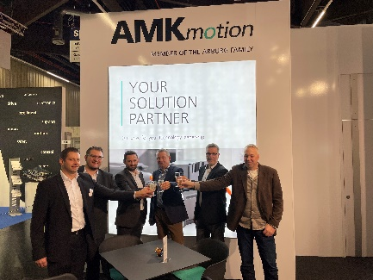
Image 4: Drive technology specialist SDT from Sweden was among those impressed by the possibilities offered by AMKmotion’s solutions: the two companies signed a contract at SPS.
Image credits: AMKmotion GmbH + Co KG

About AMKmotion
AMKmotion specialises in the development and manufacture of electric drive systems and sees itself as a long-term partner in the field of industrial mechanical engineering and plant engineering. The company’s aim is to help its customers achieve technological leadership by integrating individual and sustainable solutions.
The basis for this is AMKmotion’s hands-on mentality, combined with expertise acquired in more than 60 years of company history. We attach particular importance to personal advice and trusting cooperation with customers.
The company was founded in 1963 as AMK Arnold Müller GmbH & Co. KG. It has belonged to the Arburg family since 2021 and has operated under the name AMKmotion GmbH + Co KG since then. The portfolio includes electric drive technology, control technology and industrial automation technology. AMKmotion has a total workforce of 500 people. In addition to its headquarters in Kirchheim unter Teck, AMKmotion has production sites in Weida (Thuringia) and in Gabrovo, Bulgaria, as well as twelve branch offices around the world.

Contact
AMKmotion GmbH + Co KG
Anja Schaber
Marketing Manager
Gaußstraße 37-39
73230 Kirchheim unter Teck
Germany
www.amk-motion.com
anja.schaber@amk-motion.com
Phone +49 7021 5005 373
Mobile +49 152 5305 5372

